Evidence for Implementation and Testing Unit

Kynan Song

Cohort 16

Date:

I.T 1 – Encapsulation

I.T 2 – Inheritance

* Class
* Class that Inherits from previous class
* Object in Inherited class
* Method using inherited information

I.T 3 – Searching

Algorithm

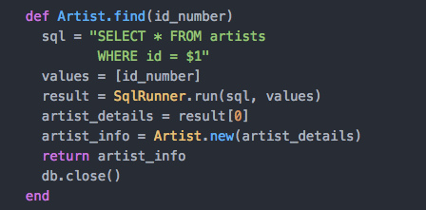

Result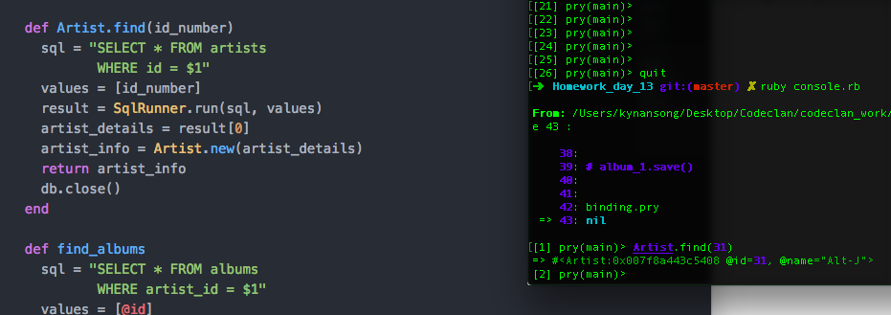

I.T 4 – Sorting

I.T 5 – Arrays

Array

Kynan MBA:Users:kynansong:Desktop:Codeclan:codeclan_work:PDA:Use of an array:Array in a program.png

Function using the array and calling it

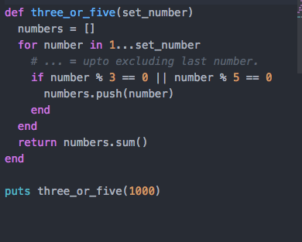

Result

Kynan MBA:Users:kynansong:Desktop:Codeclan:codeclan_work:PDA:Use of an array:Result.png

I.T 6 – Hashes

Hash, function using the hash, and calling the function

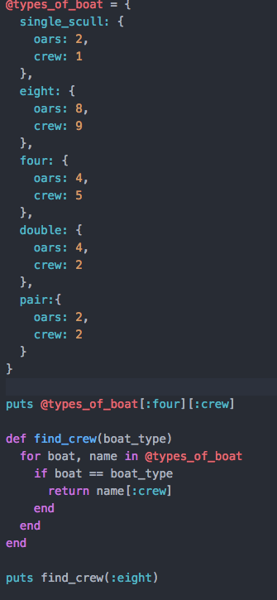

Result

Kynan MBA:Users:kynansong:Desktop:Codeclan:codeclan_work:PDA:Use of hashes:Result.png

I.T 7 – Polymorphism